**Maheshwar Venkat**



**AREAS OF INTEREST**

Product Development Application Development, Fuzzy logic and AI, Robotics and Automation

**PROJECTS**

*Automated Guided Vehicle*

A completely autonomous, self-guided industrial robot that can continuously transport products from one machine to another in an assembly line.

*Unmanned Ground Vehicle*

A wireless RF controlled all-terrain military vehicle that has built-in attack mechanisms and provides live video streaming of the battlefield.

*Generic Maze solver*

A generic line following platform which can be programmed to solve all kinds of mazes. Autonomous Robotic Arm A fully automated robotic arm with 4 DOF that can draw basic shapes.

**Sri Muthu Narayanan Balasubramanian**



**AREAS OF INTEREST**

Embedded systems, robotics and automation.

**PROJECTS**

*Simultaneous Localization and Mapping* algorithm using a Kinect sensor on a prototype indoor bot

*Autonomous Robotic Arm*

A fully automated

robotic arm with 4 DOF that can draw basic shapes.

*Automated Guided Vehicle*

A completely autonomous, self-guided industrial robot that can continuously transport products from one machine to another in an assembly line.

*Self-adjusting podium mic*

Designed and built a cost effective stand for podium microphone that automatically adjusts the position of the mic according to the speakers orientation. The face detection and tracking was implemented using Haar cascade filters in OpenCV on the RaspberryPi processor board.

*Image processing*

Built an An autonomous line follower robot with camera module for obstacle avoidance. Image processing for obstacle avoidance was implemented using the image processing toolbox in MATLAB.

**Arun Kumar Kumaresan**



**AREA OF INTEREST**

Design and Implementation of Automated systems, Manufacturing Sector – Conventional Machining

**PROJECTS**

*(3+1) DoF Parallel Manipulator Delta Robot*

Capable of performing Pick and Place with the aid of Machine Vision. Performed Payload analysis, Workspace analysis using MATLAB and verified with the actual model.

*GARP5 – Legged Bio-Mimic Robot*

Implemented PD controlled feedback system for stabilized walking capabilities. Real Time data acquiring systems, for calculating the torque and power consumption at each joint. Simulation of the robotic system on MATLAB Simulink using SimMechanics and SimScape

*Haptic Feed Arm Control*

Governing kinematic and inverse kinematic equations for the entire arm is developed using D-H table. Implemented arm with obstacle avoidance

*Petrolero, Unmanned Ground Vehicle(UGV).*

All-Terrain Vehicle that could track a specific color or object using a rotating turret. Implemented shooting mechanism which tracks an object using Image Processing

[arun16.arun@gmail.com](mailto:arun16.arun@gmail.com)

**Malarvizhi Kaniappan Chinnathai**



**AREA OF INTEREST**

Automation and Robotics

**PROJECTS**

*Obstacle detection bot with path planning ability.*

An autonomous robot capable of detecting obstacles in its pre-programmed path. *Autonomous sumo bot.*

An autonomous sumo bot that can detect the opponent robot and push it out of the arena *Colour detecting robot*

An image processing robot, which can detect and differentiate colours. Path planning was done using breadth first search.

**B Prabhakaran**

**AREA OF INTEREST**

Thermal engineering

System design

**PROJECTS**

*Heat transfer analysis:*

Heat transfer analysis of the discrete heat sources such as ICs (Integrated circuits) mounted on a PCB (Printed Circuit Board). Effect of radiation heat transfer in cooling of electronic devices was found out.

*Active stretchers for ambulance:*

Design and fabrication of Active stretchers for using in ambulance to provide safety and ride comfort to the patients by eliminating pitching produced by bumps.

*Multibody dynamic analysis of welded chain and sprocket.*

Multibody dynamic analysis of welded chain and sprocket using Msc ADAMS software simulations to find out the optimum groove angle for smooth releasing of chain from the sprocket when the chain is loaded at an inclined plane.

*LPG (Liquefied Petroleum Gas) Leak detection and automatic shut off.*

Fabrication of a device to prevent accidents due to human negligence in usage of LPG cylinders, by automatically cutting off the LPG supply from cylinder

**Ramprasath Krishnakumar**



**AREA OF INTEREST**

Robotics, Embedded systems, Custom automation both Home and Industrial grade, 3D printing, IOTs, Drones

**PROJECTS**

*Haptic feedback arm control:*

It’s more like a robotic arm controller where you wear a glove and a wrist band and the robotic arm replicates your arm’s movement.

*Resistor sorting bot.*

A bot in which if you place the unknown resistor on a fork in the machine and it puts the resistor in the corresponding box.

<https://www.youtube.com/watch?v=EJt0h4ltVm0>

*Vision telepresence robot.*

A mascot robot to give a memento to the chief guest of VISION symposium (ECE dept.)

*A normal printer hack*

A normal printer with all electronics components ripped out. Hacked it, modified it and attached a pen to the head such that the pen can move in both x and y axis. And I wrote a firmware to make it write in my handwriting.

<https://www.youtube.com/watch?v=V2zFrOcpTfo>

*Robo butler*

a robot butler which could serve at hotels.

Automating my hostel room

Disposed the door lock of my room and automated it using small IR remote. <https://www.youtube.com/watch?v=KUkLtlUPrkE>

**Satyan S**



**AREA OF INTEREST**

Circuit Designing, Microcontrollers, coding

**PROJECTS**

*LPG Safety KIT*

13 A low cost device to cut off the LPG supply, and also alert the user incase of gas leakage. This helps in averting major fires. Can be fitted to all stoves.

*Intelligent traffic management*

using RFID Intelligent traffic management and control using the data acquired about vehicles through RFID.

*Butler Bot*

A device to serve dishes in a Restaurant A robot for automation of serving dishes in restaurants using the concepts of IMAGE PROCESSING in MATLAB to provide real time solutions for path finding ,obstacle avoidance.

**Roja**

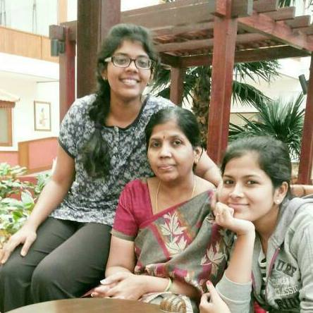

**AREA OF INTEREST**

Networks, Automation

**PROJECTS**

*Wall walking bot*

A robot capable of walking on walls

*Obstacle avoiding bots*

Robots that can navigate themselves avoiding obstacles.

**Azharuddin Humayoon**



**AREA OF INTEREST**

RTL designing

Digital circuit designing

**PROJECTS**

*Intelligent Wheel Chair*  
Move wheelchair using movement of tongue , eyeballs, hand ,head movement or Joystick Control  
*Kinect Based Natural Interface for Digital Systems*Use kinect to do live Skeletal tracking and transmit the signals to servos using Zigbee and mimick a human movements using a puppet.  
*Vision Based Text Recognition*Photograph a handwritten text document and use image processing(using OPENCV) and support vector machine(SVM) to convert the alphabets to digital Form and save in a text document.

**Md Nihal A**

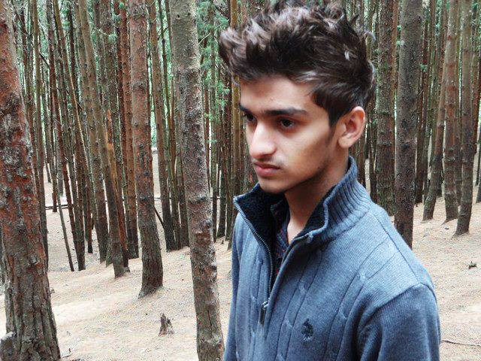

**AREA OF INTEREST**

Circuits, image processing, automation

**PROJECTS**

*Tele Presence Bot*

A bot which was designed to be maneuvered wirelessly and manually. It moves on wheels and has arms of servo motors. the servo motors move in sync and lift a tray upwards.

*Resistor Sorter*

it takes one resistor at a time and measures the resistance value of the resistor. It then transports this into one of the 8 segregation bins. It can sort upto 8 different values of resistances.

*Button Counter*

A machine which takes a pile of buttons in and outputs a number of buttons as entered by the user. The user enters his requirement through a keypad and LCD display interface. The counting is done as, the buttons are shooted at a screen which counts the number of impacts and stops the shooting when the required number is reached.

*Stereoscopic Vision*

It is the approximate implementation of how our eyes work. The goal is to calculate the distance at which objects are from the point of vision. It was done in opencv on C++.

**Sriram R**



**AREA OF INTEREST**

Robotics, Machine vision, Artificial Intelligence

**PROJECTS**

*Intelligent Automated Panic Brake Assist System*

Done using Facial Gesture Sensing in Automobiles. OpenCV is used for real time Image Processing.

*Quadrotor*

Designed and assembled a quadrotor(flying aircraft with four rotors) with live camera feed, which can be used for surveillance purposes.

*Automated system in Grinding Line.*

Suggested and designed an Automation System for the Optimization of Production in Grinding Line at Saint Gobain.

Rubik’s Cube Solver Bot

Rubik’s cube solving algorithm was written.

**Ashok**

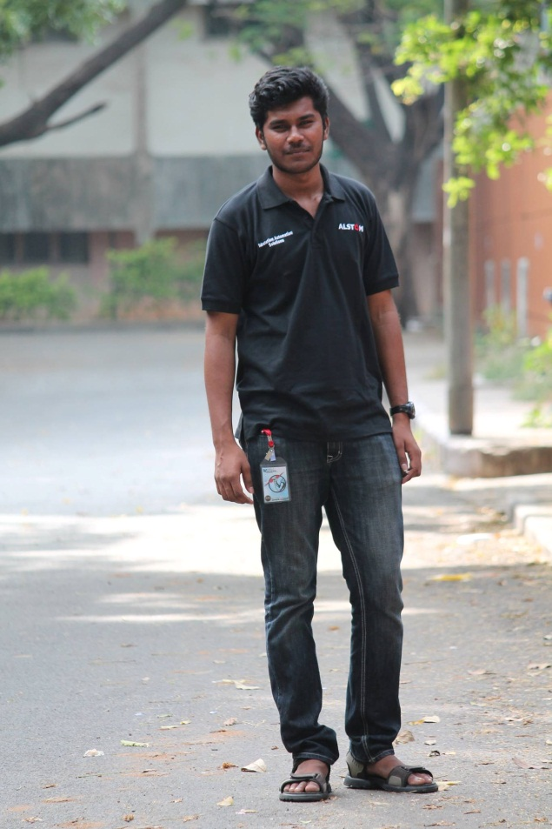

**AREA OF INTEREST**

Robotics

Automation

**PROJECTS**

*Sewer Bot*

Semi-autonomous robot for blockage removal and maintenance of underground sewer pipes

**Madhubala M**

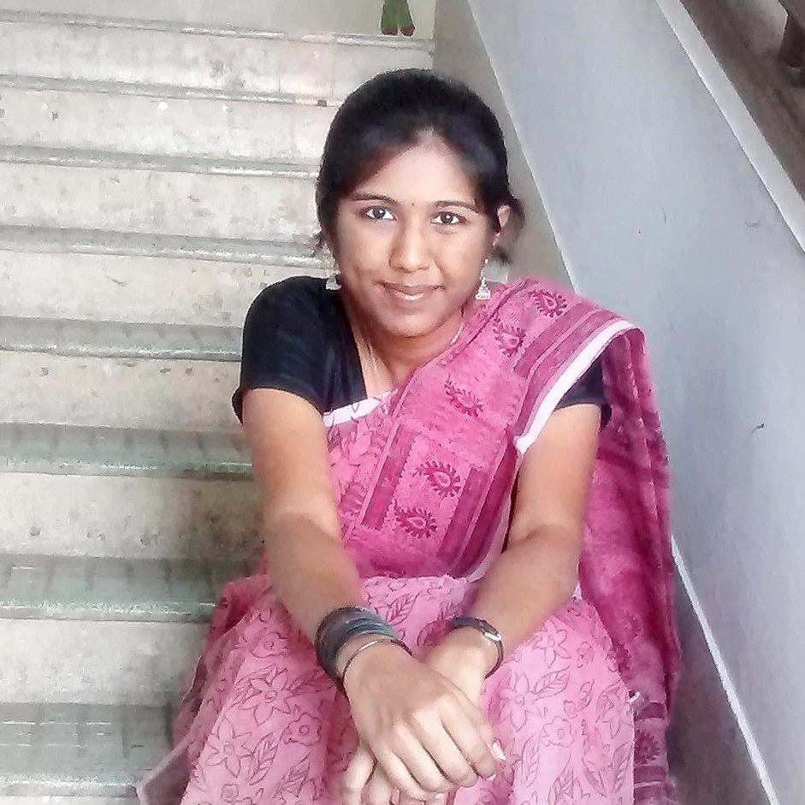

**AREA OF INTEREST**

Robotics and Automation

**PROJECTS**

*Sewer Bot*

Semi-autonomous robot for blockage removal and maintenance of underground sewer pipes

Non-linear carrier control of *Vienna rectifier*

**Avvai Anban**



**AREA OF INTEREST**

Management

**PROJECTS**

*Stereoscopic Vision*

It is the approximate implementation of how our eyes work. The goal is to calculate the distance at which objects are from the point of vision. It was done in opencv on C++.

*Virtual Paint APP*

A simple paint app using pen caps worn on fingers. It was developed on opencv on C++.